六合彩隨機號碼圖建造 (此號碼圖是完整號碼圖的五十萬分之一大小)：

Steps of Dynamically creating random maps:

Step 1. (optional step) 計算所有商戶跟特碼有關玩法的風險值/派彩，依據各項指牽涉特碼的玩法計算，排序風險值。

|  |  |
| --- | --- |
| 跟特碼有關的玩法 | 特碼直選 |
| 特碼兩面 |
| 尾數(特碼頭尾) |
| 特碼半波 |
| 色波之特碼色波 |
| 生肖(特肖) |

用殺率取商戶交集的邏輯，針對各個號碼找尋安全號碼數從高到低的交集，選出前7個對最多商戶都是安全的號碼當作特碼候選號碼(如果都選不到就隨機選，效果如同跳過這一步)。

號碼風險值示意圖：

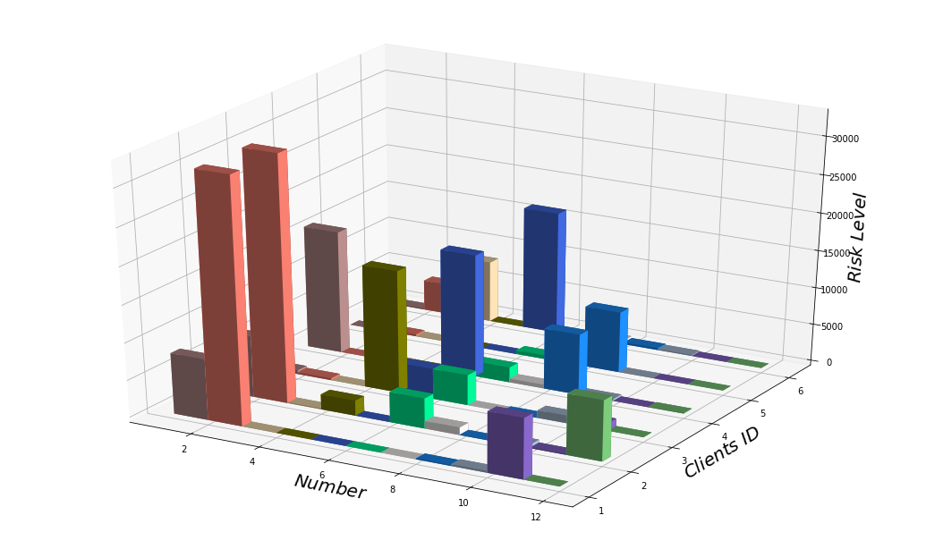

做法：

import math

import random as rd

#給出對N個商戶而言各自號碼風險的排序

( in here, 五個商戶 )

clients=[]

for j in range(5):

balls=[i+1 for i in range(49)]

rankingrisks=[]

rankingrisks=rd.sample(balls,49)

for i in range(len(rankingrisks)):

balls.remove(rankingrisks[i])

clients.append(rankingrisks)

#各商戶取風險低的50%

clientinhalf=[clients[i][:math.floor(len(clients[i])/2)] for i in range(len(clients))]

#建造各號碼對應的交集數量向量

lowriskpoints=[0]*49

#把每個商戶風險低的號碼去數一數

for w in range(len(clientinhalf)):

print(clientinhalf[w])

for t in range(len(clientinhalf[w])):

lowriskpoints[clientinhalf[w][t]-1]+=1

#列出每個號碼，有多少個商戶對各自來說是風險低的統計表

print(lowriskpoints)

#排序這個表，找出對應前幾個安全的號碼

print(sorted(lowriskpoints))

An example when N=20 (二十個商戶):

[26, 14, 24, 18, 38, 13, 16, 37, 28, 34, 25, 10, 19, 49, 30, 35, 9, 36, 43, 6, 3, 33, 5, 2]

[1, 37, 29, 7, 31, 27, 23, 15, 25, 10, 5, 41, 40, 39, 28, 18, 21, 48, 44, 16, 46, 9, 2, 35]

[26, 28, 7, 3, 20, 25, 32, 49, 37, 16, 17, 5, 22, 31, 8, 46, 10, 9, 35, 6, 47, 19, 29, 24]

[25, 21, 48, 43, 11, 8, 2, 28, 9, 40, 22, 44, 36, 6, 7, 42, 10, 18, 29, 33, 14, 17, 3, 45]

[37, 48, 19, 35, 10, 21, 43, 49, 7, 39, 28, 13, 16, 20, 22, 2, 17, 6, 47, 26, 14, 1, 33, 34]

[26, 3, 20, 27, 8, 15, 43, 7, 22, 30, 16, 6, 14, 21, 36, 47, 34, 13, 35, 39, 10, 17, 45, 29]

[46, 12, 38, 49, 32, 36, 11, 8, 33, 30, 27, 7, 39, 47, 4, 13, 25, 19, 28, 17, 29, 10, 35, 41]

[6, 38, 44, 43, 7, 10, 39, 42, 29, 11, 26, 37, 46, 13, 25, 22, 24, 48, 33, 4, 40, 5, 35, 19]

[48, 12, 22, 8, 37, 15, 16, 34, 18, 24, 14, 41, 4, 3, 31, 33, 2, 44, 30, 27, 9, 32, 21, 1]

[2, 3, 22, 14, 36, 17, 1, 39, 45, 30, 35, 8, 40, 32, 13, 27, 28, 18, 47, 23, 37, 7, 15, 10]

[39, 2, 48, 24, 11, 22, 13, 41, 4, 26, 35, 19, 12, 44, 9, 43, 23, 49, 15, 20, 21, 27, 10, 29]

[5, 31, 28, 15, 19, 24, 41, 48, 21, 33, 30, 18, 9, 49, 27, 43, 13, 44, 29, 42, 46, 12, 6, 26]

[43, 2, 21, 47, 25, 19, 44, 10, 12, 4, 33, 39, 38, 16, 41, 22, 9, 3, 7, 30, 24, 49, 27, 11]

[25, 21, 6, 39, 48, 33, 45, 11, 40, 20, 47, 12, 41, 17, 8, 5, 22, 10, 2, 23, 31, 29, 7, 15]

[18, 21, 13, 46, 12, 33, 15, 23, 17, 25, 29, 38, 1, 20, 34, 14, 2, 16, 49, 35, 26, 5, 9, 44]

[33, 28, 18, 15, 27, 9, 31, 42, 21, 35, 29, 25, 39, 17, 26, 20, 5, 32, 43, 38, 44, 7, 34, 41]

[35, 14, 49, 34, 16, 31, 24, 29, 46, 40, 41, 12, 5, 25, 33, 17, 11, 18, 30, 20, 32, 44, 3, 39]

[23, 34, 33, 36, 40, 41, 5, 35, 6, 13, 14, 1, 38, 19, 25, 20, 48, 21, 27, 45, 29, 17, 30, 2]

[45, 15, 8, 17, 29, 28, 46, 38, 48, 9, 41, 22, 19, 39, 16, 37, 5, 43, 1, 2, 7, 25, 13, 27]

[41, 20, 26, 37, 2, 30, 35, 14, 22, 44, 1, 13, 7, 38, 25, 11, 15, 24, 27, 10, 45, 46, 21, 4]

#各個號碼(from 1 🡪49 )被多少個商戶(1~20)視為安全號碼：

[8, 13, 8, 6, 11, 9, 13, 8, 11, 13, 8, 8, 12, 10, 11, 10, 12, 9, 10, 10, 13, 12, 6, 9, 14, 10, 12, 10, 14, 10, 7, 6, 13, 8, 14, 6, 9, 9, 12, 7, 12, 4, 10, 11, 7, 9, 7, 10, 9]

#重新排序風險值 (同風險值的號碼排序採隨機而非大小順序，未於此處列出)

[4, 6, 6, 6, 6, 7, 7, 7, 7, 8, 8, 8, 8, 8, 8, 9, 9, 9, 9, 9, 9, 9, 10, 10, 10, 10, 10, 10, 10, 10, 10, 11, 11, 11, 11, 12, 12, 12, 12, 12, 12, 13, 13, 13, 13, 13, 14, 14, 14]

Step 2. Re-grouping what’s left in 1~49 into 6 groups with 7 numbers in each of them.

Step 3. Assign each group as candidates for each position.

e.g.

特別碼候選名單 [14, 10, 31, 43, 27, 37, 3] All safe numbers by selection

正碼1候選名單 [2, 28, 9, 33, 21, 46, 22]

正碼2候選名單 [12, 1, 36, 8, 20, 44, 40]

正碼3候選名單 [17, 16, 4, 18, 48, 39, 29]

正碼4候選名單 [23, 13, 47, 25, 42, 38, 32]

正碼5候選名單 [45, 11, 49, 19, 34, 41, 7]

正碼6候選名單 [6, 5, 15, 35, 24, 26, 30]

Creating this map with 823543 numbers in it.

Randmap = [7 groups with 7 numbers in each one of them]

各跨位置的玩法拆解方式：

|  |  |  |
| --- | --- | --- |
| 生肖 | 一肖 |  |
| 二肖連 |  |
| 三肖連 |  |
| 四肖連 |  |
| 總肖 | 依據號拆解 |
| 正肖 | 依據玩法拆解 |
| 尾數 | 二連尾 |  |
| 三連尾 |  |
| 四連尾 |  |
| 連碼 | 三全中 |  |
| 三中二 |  |
| 二全中 |  |
| 二中特 |  |
| 特串 |  |
| 色波 | 七色波 | 依據號拆解 |
|  |  |  |
|  |  |  |
|  |  |  |

各玩法拆解

生肖一肖

玩家選擇Mouse=[11, 23, 35, 47]

gotit=0

for cp1 in combinations(randmap[0],1):

for cp2 in combinations(randmap[1],1):

for cp3 in combinations(randmap[2],1):

for cp4 in combinations(randmap[3],1):

for cp5 in combinations(randmap[4],1):

for cp6 in combinations(randmap[5],1):

for cp7 in combinations(randmap[6],1):

if (cp1[0] in mouse) or (cp2[0] in mouse) or (cp3[0] in mouse) or (cp4[0] in mouse) or (cp5[0] in mouse) or (cp6[0] in mouse):

gotit+=1

print(gotit)

Total=304927

For randmap (正碼與特碼各自的候選號碼) = [[35, 20, 12, 8, 30, 5, 15], [9, 14, 22, 31, 42, 29, 16], [10, 28, 26, 46, 47, 17, 23], [24, 48, 7, 21, 41, 3, 4], [36, 11, 44, 40, 13, 2, 43], [34, 19, 25, 18, 39, 32, 38], [49, 6, 1, 33, 45, 27, 37]]

Total= 391363=

For randmap (正碼與特碼各自的候選號碼) = [[42, 44, 13, 29, 24, 38, 26], [9, 8, 10, 39, 31, 37, 48], [34, 40, 11, 12, 4, 28, 17], [20, 23, 5, 30, 49, 7, 46], [35, 1, 43, 15, 45, 21, 19], [33, 41, 36, 2, 22, 32, 16], [6, 47, 27, 14, 3, 25, 18]]

Total=304927 🡪 Min

For randmap (正碼與特碼各自的候選號碼) =[[42, 44, 13, 29, 24, 38, 26], [9, 8, 10, 39, 31, 37, 48], [34, 35, 11, 23, 4, 28, 47], [20, 12, 5, 30, 49, 7, 46], [40, 1, 43, 15, 45, 21, 19], [33, 41, 36, 2, 22, 32, 16], [6, 17, 27, 14, 3, 25, 18]]

Total=470596 (= 4*7^6) 🡪 Max

生肖二連肖

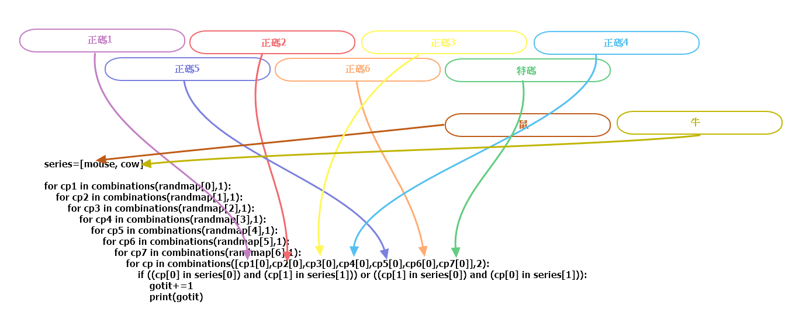

Ballposition(正碼與特碼各自的候選號碼)=[[42, 44, 13, 29, 24, 38, 26], [9, 8, 10, 39, 31, 37, 48], [34, 35, 11, 23, 4, 28, 47], [20, 12, 5, 30, 49, 7, 46], [40, 1, 43, 15, 45, 21, 19], [33, 41, 36, 2, 22, 32, 16], [6, 17, 27, 14, 3, 25, 18]]

randmap=ballposition

#玩家選擇 【鼠、牛】

mouse = [11, 23, 35, 47]

cow = [10, 22, 34, 46]

series=[mouse, cow]

print (series)

#print(randmap)

gotit=0

for cp1 in combinations(randmap[0],1):

for cp2 in combinations(randmap[1],1):

for cp3 in combinations(randmap[2],1):

for cp4 in combinations(randmap[3],1):

for cp5 in combinations(randmap[4],1):

for cp6 in combinations(randmap[5],1):

for cp7 in combinations(randmap[6],1):

for cp in combinations([cp1[0],cp2[0],cp3[0],cp4[0],cp5[0],cp6[0],cp7[0]],2):

if ((cp[0] in series[0]) and (cp[1] in series[1])) or ((cp[1] in series[0]) and (cp[0] in series[1])):

gotit+=1

print(gotit)

Total=201684

生肖三連肖

#玩家選擇【鼠、牛、虎】

mouse = [11, 23, 35, 47]

cow = [10, 22, 34, 46]

tiger = [9, 21, 33, 45]

series=[mouse, cow, tiger]

print (series)

#print(randmap)

gotit=0

for cp1 in combinations(randmap[0],1):

for cp2 in combinations(randmap[1],1):

for cp3 in combinations(randmap[2],1):

for cp4 in combinations(randmap[3],1):

for cp5 in combinations(randmap[4],1):

for cp6 in combinations(randmap[5],1):

for cp7 in combinations(randmap[6],1):

for cp in combinations([cp1[0],cp2[0],cp3[0],cp4[0],cp5[0],cp6[0],cp7[0]],3):

if ((cp[0] in series[0]) and (cp[1] in series[1]) and (cp[2] in series[2])):

gotit+=1

print(gotit)

elif ((cp[0] in series[0]) and (cp[2] in series[1]) and (cp[1] in series[2])):

gotit+=1

print(gotit)

elif ((cp[1] in series[0]) and (cp[0] in series[1]) and (cp[2] in series[2])):

gotit+=1

print(gotit)

elif ((cp[1] in series[0]) and (cp[2] in series[1]) and (cp[0] in series[2])):

gotit+=1

print(gotit)

elif ((cp[2] in series[0]) and (cp[0] in series[1]) and (cp[1] in series[2])):

gotit+=1

print(gotit)

elif ((cp[2] in series[0]) and (cp[1] in series[1]) and (cp[0] in series[2])):

gotit+=1

print(gotit)

Total= 96040

生肖四連肖

The same

生肖總肖

ballposition=[[42, 44, 13, 29, 24, 38, 26], [9, 8, 10, 39, 31, 37, 48], [34, 35, 11, 23, 4, 28, 47], [20, 12, 5, 30, 49, 7, 46], [40, 1, 43, 15, 45, 21, 19], [33, 41, 36, 2, 22, 32, 16], [6, 17, 27, 14, 3, 25, 18]]

randmap=ballposition

在建造map之後就對此玩法進行統計，知道所有234肖~總肖對應的號碼。

#統計所有生肖的個數，再分配到此玩法的各選項(234肖、總肖單etc)

mouse = [11, 23, 35, 47]

cow = [10, 22, 34, 46]

tiger = [9, 21, 33, 45]

rabbit =[8, 20, 32, 44]

dragon = [7, 19, 31, 43]

snake = [6, 18, 30, 42]

horse =[5, 17, 29, 41]

goat = [4, 16, 28, 40]

monkey =[3, 15, 27, 39]

chicken = [2, 14, 26, 38]

dog = [1, 13, 25, 37, 49]

pig= [12, 24, 36, 48]

series=[mouse, cow, tiger, rabbit, dragon, snake, horse, goat, monkey, chicken, dog, pig]

#print(randmap)

#統計此局map內所有的234肖, 5肖, 6肖, 7肖, 總肖單, 總肖雙。玩家選擇任何一個選項，就增加該選項的派彩金額不用再去看號碼。

gotit=0

for cp1 in combinations(randmap[0],1):

for cp2 in combinations(randmap[1],1):

for cp3 in combinations(randmap[2],1):

for cp4 in combinations(randmap[3],1):

for cp5 in combinations(randmap[4],1):

for cp6 in combinations(randmap[5],1):

for cp7 in combinations(randmap[6],1):

numberset=[cp1[0],cp2[0],cp3[0],cp4[0],cp5[0],cp6[0],cp7[0]]

counteach=[0]*12

countall=0

for j in range(12):

for i in range(7):

if numberset[i] in series[j]:

counteach[j]+=1

for k in range(12):

if counteach[k]>=1:

countall+=1

#print(counteach, countall)

生肖正肖

ballposition=[[5, 43, 15, 40, 45, 34, 39],

[33, 30, 28, 1, 48, 3, 35],

[13, 7, 12, 20, 37, 9, 2],

[8, 17, 44, 31, 32, 49, 10],

[36, 27, 24, 11, 41, 23, 16],

[26, 21, 6, 46, 25, 47, 22],

[19, 38, 42, 14, 4, 18, 29]]

randmap=[0]*7

mouse = [11, 23, 35, 47]

cow = [10, 22, 34, 46]

tiger = [9, 21, 33, 45]

rabbit =[8, 20, 32, 44]

dragon = [7, 19, 31, 43]

snake = [6, 18, 30, 42]

horse =[5, 17, 29, 41]

goat = [4, 16, 28, 40]

monkey =[3, 15, 27, 39]

chicken = [2, 14, 26, 38]

dog = [1, 13, 25, 37, 49]

pig= [12, 24, 36, 48]

series=[mouse, cow, tiger, rabbit, dragon, snake, horse, goat, monkey, chicken, dog, pig]

seriesname=['mouse', 'cow', 'tiger', 'rabbit', 'dragon', 'snake', 'horse', 'goat', 'monkey', 'chicken', 'dog', 'pig']

#playerselection=mouse

#locatemouse=[[0]*4]*pow(7,6)

count=0

for se in range(len(series)):

for i in range(len(series[se])):

for j in range(len(randmap)):

randmap=[ballposition[0],ballposition[1],ballposition[2],ballposition[3],ballposition[4],ballposition[5],ballposition[6]]

#當某生肖的某數略在某位置，把那個數字直接取代那個位置的所有候選清單，跑出所有跟該數字有關的號碼

if series[se][i] in randmap[j]:

randmap[j]=[series[se][i]]

for cp1 in combinations(randmap[0],1):

for cp2 in combinations(randmap[1],1):

for cp3 in combinations(randmap[2],1):

for cp4 in combinations(randmap[3],1):

for cp5 in combinations(randmap[4],1):

for cp6 in combinations(randmap[5],1):

for cp7 in combinations(randmap[6],1):

numberset=[cp1[0], cp2[0], cp3[0], cp4[0], cp5[0], cp6[0],cp7[0]]

#for ks in range(7):

#if numberset[ks]==23:

count+=1

#print(numberset, [len(randmap[0]),len(randmap[1]),len(randmap[2]),len(randmap[3]),len(randmap[4]),len(randmap[5]),len(randmap[6])])

print(count)

尾數二連尾

|  |  |
| --- | --- |
| 0尾 | 1尾 |

#玩家選擇

gotit=0

for cp1 in combinations(randmap[0],1):

for cp2 in combinations(randmap[1],1):

for cp3 in combinations(randmap[2],1):

for cp4 in combinations(randmap[3],1):

for cp5 in combinations(randmap[4],1):

for cp6 in combinations(randmap[5],1):

for cp7 in combinations(randmap[6],1):

numberset=[cp1[0],cp2[0],cp3[0],cp4[0],cp5[0],cp6[0],cp7[0]]

gottwo=[0,0]

two=[0, 0]

for i in range(7):

if (numberset[i] in [10,20,30,40]):

gottwo[0]+=1

elif (numberset[i] in [1,11,21,31,41]):

gottwo[1]+=1

for j in range(2):

if gottwo[j]>=1:

two[j]=1

if two[0]+two[1]==2:

gotit+=1

print(gotit)

total= 197323 for randmap=[[42, 44, 13, 29, 24, 38, 26], [9, 8, 10, 39, 31, 37, 48], [34, 35, 11, 23, 4, 28, 47], [20, 12, 5, 30, 49, 7, 46], [40, 1, 43, 15, 45, 21, 19], [33, 41, 36, 2, 22, 32, 16], [6, 17, 27, 14, 3, 25, 18]]

三連尾：

Same

四連尾：

Same

五不中：

#玩家選擇

notthisfive=[1,2,3,4,5]

gotit=0

for cp1 in combinations(randmap[0],1):

for cp2 in combinations(randmap[1],1):

for cp3 in combinations(randmap[2],1):

for cp4 in combinations(randmap[3],1):

for cp5 in combinations(randmap[4],1):

for cp6 in combinations(randmap[5],1):

for cp7 in combinations(randmap[6],1):

numberset=[cp1[0],cp2[0],cp3[0],cp4[0],cp5[0],cp6[0],cp7[0]]

if (notthisfive[0] not in numberset) and (notthisfive[1] not in numberset) and (notthisfive[2] not in numberset) and (notthisfive[3] not in numberset) and (notthisfive[4] not in numberset):

gotit+=1

print(gotit)

total for this: 381024

六不中~十不中：

The same

連碼三全中

#玩家選擇

threego=[12,23,9]

gotit=0

for cp1 in combinations(randmap[0],1):

for cp2 in combinations(randmap[1],1):

for cp3 in combinations(randmap[2],1):

for cp4 in combinations(randmap[3],1):

for cp5 in combinations(randmap[4],1):

for cp6 in combinations(randmap[5],1):

#for cp7 in combinations(randmap[6],1):

numberset=[cp1[0],cp2[0],cp3[0],cp4[0],cp5[0],cp6[0]]

if (threego[0] in numberset) and (threego[1] in numberset) and (threego[2] in numberset):

gotit+=1

print(gotit)

total=343

二全中

#玩家選擇

twogo=[12,23]

gotit=0

for cp1 in combinations(randmap[0],1):

for cp2 in combinations(randmap[1],1):

for cp3 in combinations(randmap[2],1):

for cp4 in combinations(randmap[3],1):

for cp5 in combinations(randmap[4],1):

for cp6 in combinations(randmap[5],1):

#for cp7 in combinations(randmap[6],1):

numberset=[cp1[0],cp2[0],cp3[0],cp4[0],cp5[0],cp6[0]]

if (twogo[0] in numberset) and (twogo[1] in numberset):

gotit+=1

print(gotit)

total=2401

三中二

#玩家選擇

playerselection=[12,23,42]

gotit=0

for cp1 in combinations(randmap[0],1):

for cp2 in combinations(randmap[1],1):

for cp3 in combinations(randmap[2],1):

for cp4 in combinations(randmap[3],1):

for cp5 in combinations(randmap[4],1):

for cp6 in combinations(randmap[5],1):

#for cp7 in combinations(randmap[6],1):

numberset=[cp1[0],cp2[0],cp3[0],cp4[0],cp5[0],cp6[0]]

if ((playerselection[0] in numberset) and (playerselection[1] in numberset) and (playerselection[1] not in numberset)) or ((playerselection[0] in numberset) and (playerselection[1] not in numberset) and (playerselection[1] in numberset)) or ((playerselection[0] not in numberset) and (playerselection[1] in numberset) and (playerselection[1] in numberset)):

gotit+=1

print(gotit)

Total in this case=14406

特串

#玩家選擇

playerselection=[17,42]

gotit=0

for cp1 in combinations(randmap[0],1):

for cp2 in combinations(randmap[1],1):

for cp3 in combinations(randmap[2],1):

for cp4 in combinations(randmap[3],1):

for cp5 in combinations(randmap[4],1):

for cp6 in combinations(randmap[5],1):

for cp7 in combinations(randmap[6],1):

numberset=[cp1[0],cp2[0],cp3[0],cp4[0],cp5[0],cp6[0]]

if ((playerselection[0] in numberset) and (playerselection[1] in cp7)) or ((playerselection[1] in numberset) and (playerselection[0] in cp7)):

gotit+=1

print(gotit)

Total for this case=16807

二中特

二全中跟特串合併。

色波

特碼色波、正1~正6色波，各自該位置計算。

色波七色波

ballposition=[[42, 44, 13, 29, 24, 38, 26], [9, 8, 10, 39, 31, 37, 48], [34, 35, 11, 23, 4, 28, 47], [20, 12, 5, 30, 49, 7, 46], [40, 1, 43, 15, 45, 21, 19], [33, 41, 36, 2, 22, 32, 16], [6, 17, 27, 14, 3, 25, 18]]

randmap=ballposition

#ending=[[10,20,30,40], [1,11,21,31,41], [2,12,22,32,42], [3,13,23,33,43], [4,14,24,34,44], [5,15,25,35,45], [6,16,26,36,46], [7,17,27,37,47], [8,18,28,38,48], [9,19,29,39,49]]

red=[1,2,7,8,12,13,18,19,23,24,29,30,34,35,40,45,46]

blue=[3,4,9,10,14,15,20,25,26,31,36,37,41,42,47,48]

green=[5,6,11,16,17,21,22,27,28,32,33,38,39,43,44,49]

print(len(red), len(blue), len(green))

#playerselection=red

#建造【紅、藍、綠、和】統計陣列

winlossbycoloranddrawcount=[0]*4 # [red wins, blue wins, green wins, draw]

for cp1 in combinations(randmap[0],1):

for cp2 in combinations(randmap[1],1):

for cp3 in combinations(randmap[2],1):

for cp4 in combinations(randmap[3],1):

for cp5 in combinations(randmap[4],1):

for cp6 in combinations(randmap[5],1):

for cp7 in combinations(randmap[6],1):

numberset=[cp1[0],cp2[0],cp3[0],cp4[0],cp5[0],cp6[0], cp7[0]]

#建造【紅、藍、綠】次數計算陣列

countcolorball=[0,0,0] #[red count, blue count, green count]

for s in range(6):

if numberset[s] in red:

countcolorball[0]+=1

elif numberset[s] in blue:

countcolorball[1]+=1

elif numberset[s] in green:

countcolorball[2]+=1

if numberset[6] in red:

countcolorball[0]+=1.5

elif numberset[6] in blue:

countcolorball[1]+=1.5

elif numberset[6] in green:

countcolorball[2]+=1.5

if (countcolorball[1]==3 and countcolorball[2]==3 and countcolorball[0]==1.5) or (countcolorball[1]==3 and countcolorball[0]==3 and countcolorball[2]==1.5) or (countcolorball[0]==3 and countcolorball[2]==3 and countcolorball[1]==1.5):

winlossbycoloranddrawcount[3]+=1

elif countcolorball[0]>countcolorball[1] and countcolorball[0]>countcolorball[2]:

winlossbycoloranddrawcount[0]+=1

elif countcolorball[1]>countcolorball[0] and countcolorball[1]>countcolorball[2]:

winlossbycoloranddrawcount[1]+=1

elif countcolorball[2]>countcolorball[0] and countcolorball[2]>countcolorball[1]:

winlossbycoloranddrawcount[2]+=1

print(countcolorball, winlossbycoloranddrawcount)

A piece of what this looks like:

[red, blue, green] [red wins, blue wins, green wins, draw]

[2, 5.5, 0] [259120, 266875, 275444, 22066]

[2, 5.5, 0] [259120, 266876, 275444, 22066]

[2, 5.5, 0] [259120, 266877, 275444, 22066]

[3.5, 4, 0] [259120, 266878, 275444, 22066]

[2, 4, 1.5] [259120, 266879, 275444, 22066]

[2, 4, 1.5] [259120, 266880, 275444, 22066]

[2, 4, 1.5] [259120, 266881, 275444, 22066]

[2, 5.5, 0] [259120, 266882, 275444, 22066]

[2, 5.5, 0] [259120, 266883, 275444, 22066]

[2, 5.5, 0] [259120, 266884, 275444, 22066]

[3.5, 4, 0] [259120, 266885, 275444, 22066]

[3, 3, 1.5] [259120, 266885, 275444, 22067]

[3, 3, 1.5] [259120, 266885, 275444, 22068]

[3, 3, 1.5] [259120, 266885, 275444, 22069]

[3, 4.5, 0] [259120, 266886, 275444, 22069]

[3, 4.5, 0] [259120, 266887, 275444, 22069]

[3, 4.5, 0] [259120, 266888, 275444, 22069]

[4.5, 3, 0] [259121, 266888, 275444, 22069]

[2, 3, 2.5] [259121, 266889, 275444, 22069]

[2, 3, 2.5] [259121, 266890, 275444, 22069]

[2, 3, 2.5] [259121, 266891, 275444, 22069]

[2, 4.5, 1] [259121, 266892, 275444, 22069]

[2, 4.5, 1] [259121, 266893, 275444, 22069]

[2, 4.5, 1] [259121, 266894, 275444, 22069]

[3.5, 3, 1] [259122, 266894, 275444, 22069]

[2, 3, 2.5] [259122, 266895, 275444, 22069]

[2, 3, 2.5] [259122, 266896, 275444, 22069]

[2, 3, 2.5] [259122, 266897, 275444, 22069]

[2, 4.5, 1] [259122, 266898, 275444, 22069]

[2, 4.5, 1] [259122, 266899, 275444, 22069]

[2, 4.5, 1] [259122, 266900, 275444, 22069]

[3.5, 3, 1] [259123, 266900, 275444, 22069]

[2, 3, 2.5] [259123, 266901, 275444, 22069]

[2, 3, 2.5] [259123, 266902, 275444, 22069]

[2, 3, 2.5] [259123, 266903, 275444, 22069]

[2, 4.5, 1] [259123, 266904, 275444, 22069]

[2, 4.5, 1] [259123, 266905, 275444, 22069]

[2, 4.5, 1] [259123, 266906, 275444, 22069]

[3.5, 3, 1] [259124, 266906, 275444, 22069]

Total for this random map setting: 紅色贏259124，藍色贏 266906，綠色贏275444，和局22069